**John Perkins**

**Bonus Assignment 2**

**PREDICT 422**

**3/2/18**

The objective of this assignment is to analyze the GermanCredit data set in the package caret. There are a couple of steps to take. The first is to build a regression model to predict the variable “Amount”. Then the steps that are taken in 2A-C are replicated 1,000 times then the distributions are plot. Then beta of all coefficients using the 1,000 MuTaTe runs are computed. The results and key learnings were summarized.

**Developing the model and plotting distributions:**

The regression model was built and ran 1,000 times as was stipulated in Parts 2a-c. All 1,000 results were saved so that the data could have the distributions plotted.

**Distributions of Coefficients:**

The coefficient estimates are not stable as is represented in the graph below. Even with 1,000 iterations, there is no consistent estimate except for the coefficient duration.

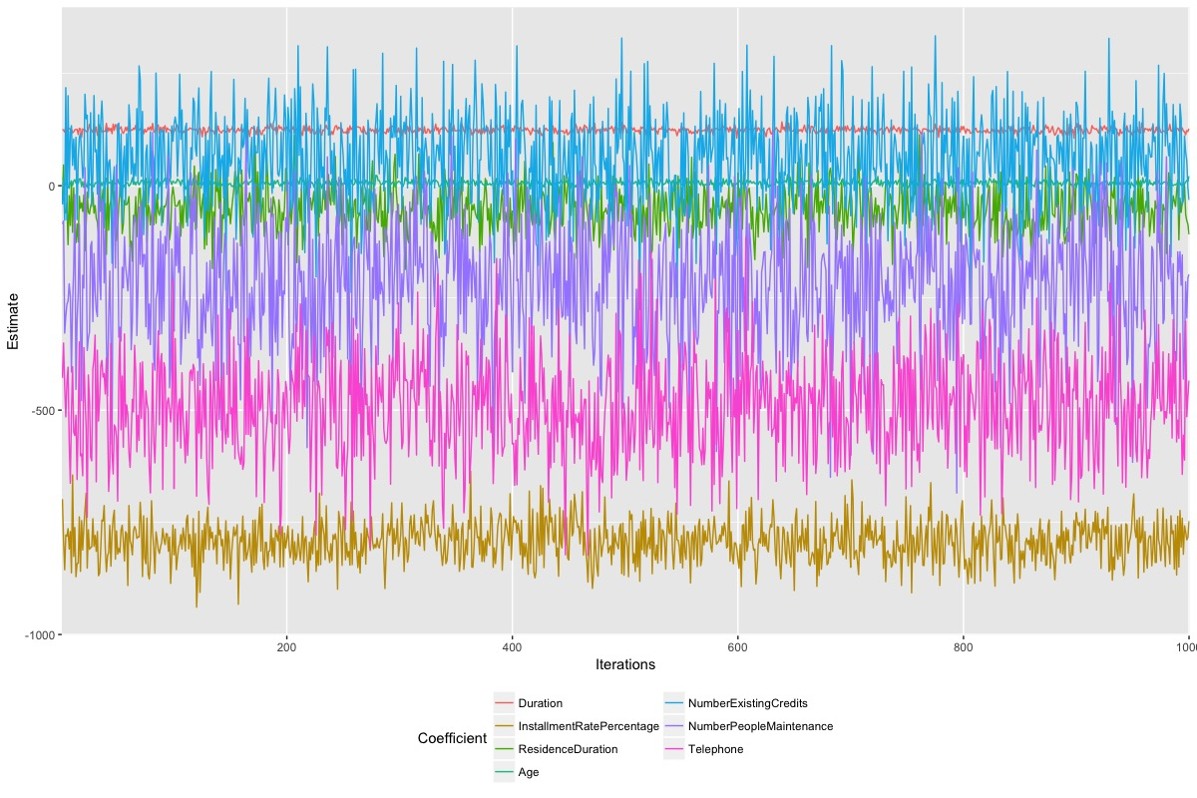

**Holdout R-Squared:**

The two charts below show the R-Squared and Adjusted R-Squared values over the training and test data sets. Both graphs show a considerable amount of instability.

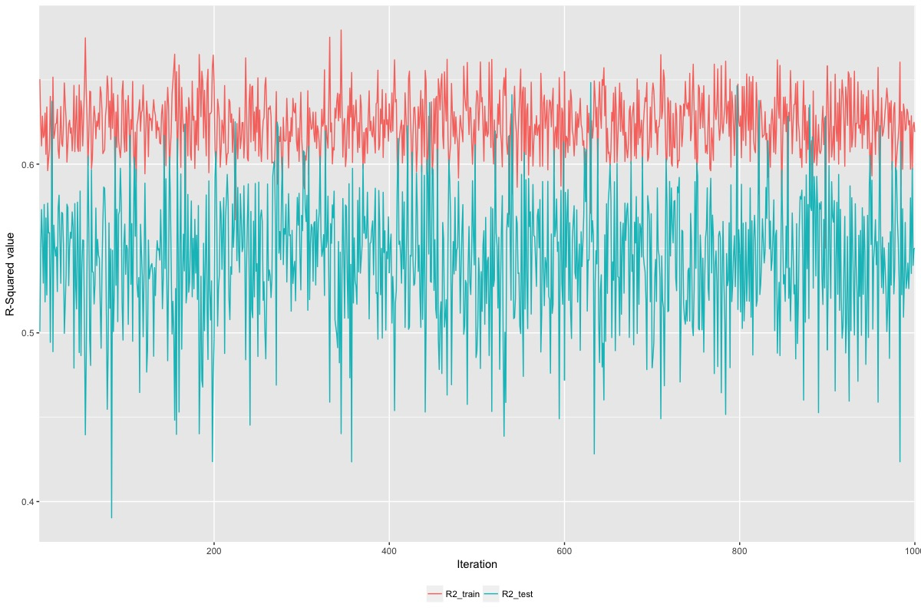

**Adjusted R-Squared:**

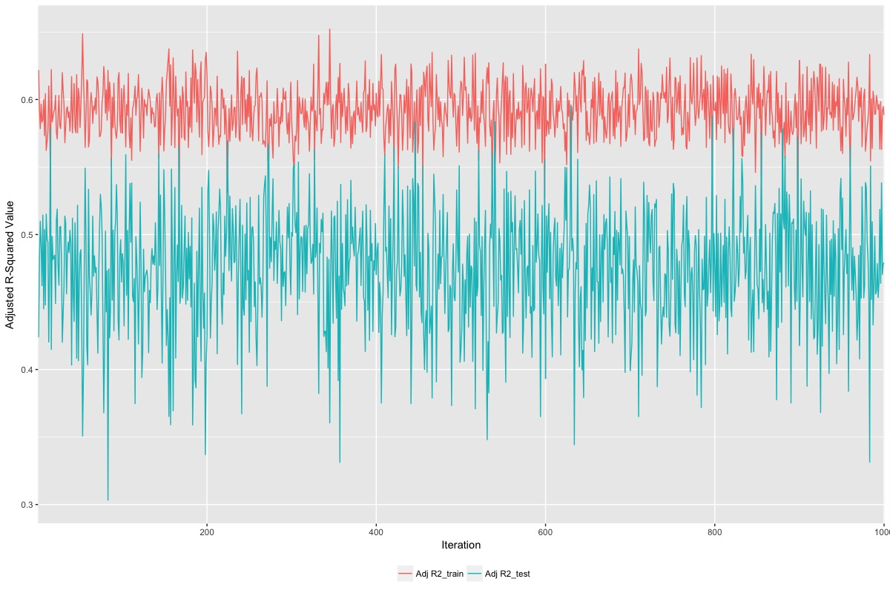

**Percent Fall in the R-Squared Value for the Training vs. Test Set:**

When evaluating the chart below, there are iterations where the test set R-Squared value exceeds the R-Squared value of the training set.

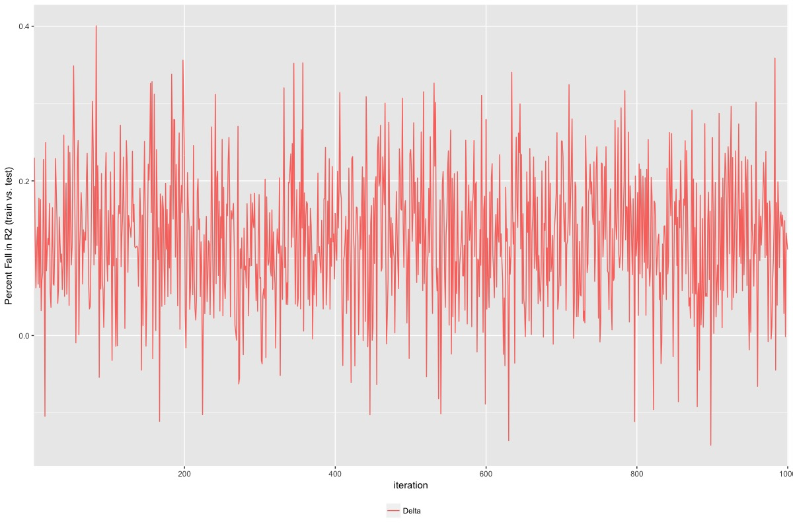

**Compute the Mean Beta of all Coefficients and Compare:**

Below is the table calculated with the data that has the coefficient estimate comparison. The coefficient estimates on the full set of data are similar to the mean coefficient estimates on the 1,000 iterations.

| |All_Data_Fit| mean| min| q25| q75| max|

|:---------------------------------------------|------------:|-----------:|--------:|--------:|--------:|--------:|

|(Intercept) | 7074.53| 7073.91| 3015.41| 6296.03| 7855.96| 11305.68|

|Duration | 124.63| 124.18| 105.90| 120.12| 127.86| 142.30|

|InstallmentRatePercentage | -794.60| -792.24| -939.08| -824.41| -760.87| -635.93|

|ResidenceDuration | -51.54| -49.60| -186.49| -81.22| -19.68| 136.08|

|Age | 6.36| 6.19| -10.23| 2.51| 9.73| 24.88|

|NumberExistingCredits | 60.76| 61.85| -276.25| -5.14| 128.37| 333.96|

|NumberPeopleMaintenance | -209.32| -218.21| -684.68| -308.64| -126.40| 122.59|

|Telephone | -496.50| -494.54| -823.06| -571.35| -419.63| -115.29|

|ForeignWorker | -302.06| -290.73| -1163.83| -462.78| -117.25| 443.67|

|ClassGood | -369.92| -371.29| -854.68| -470.79| -276.01| 126.74|

|CheckingAccountStatus.lt.0 | -203.33| -204.07| -532.02| -291.74| -116.89| 183.30|

|CheckingAccountStatus.0.to.200 | 141.10| 143.99| -206.59| 56.51| 229.46| 519.56|

|CheckingAccountStatus.gt.200 | -641.47| -634.90| -1142.59| -737.05| -536.78| -187.75|

|CheckingAccountStatus.none | NA| NA| NA| NA| NA| NA|

|CreditHistory.NoCredit.AllPaid | 757.07| 755.64| -540.10| 533.47| 974.17| 2062.82|

|CreditHistory.ThisBank.AllPaid | -148.84| -155.44| -1074.56| -334.77| 28.21| 613.79|

|CreditHistory.PaidDuly | -58.53| -60.80| -464.23| -143.48| 23.21| 337.01|

|CreditHistory.Delay | 76.06| 87.04| -734.45| -52.37| 228.68| 719.42|

|CreditHistory.Critical | NA| NA| NA| NA| NA| NA|

|Purpose.NewCar | -1837.99| -1818.97| -6320.74| -2438.77| -1217.18| 2002.86|

|Purpose.UsedCar | -1118.76| -1102.20| -5378.97| -1700.27| -501.50| 2549.11|

|Purpose.Furniture.Equipment | -1869.15| -1849.00| -6410.97| -2483.60| -1209.89| 1833.25|

|Purpose.Radio.Television | -2100.81| -2078.72| -6615.28| -2688.99| -1459.66| 1581.40|

|Purpose.DomesticAppliance | -2511.65| -2498.40| -7028.37| -3147.59| -1818.45| 930.91|

|Purpose.Repairs | -1774.11| -1758.77| -6186.78| -2435.79| -1070.47| 2318.66|

|Purpose.Education | -1980.28| -1977.34| -6368.84| -2626.38| -1360.44| 1706.58|

|Purpose.Vacation | NA| NA| NA| NA| NA| NA|

|Purpose.Retraining | -2193.13| -2167.48| -7107.88| -2898.56| -1435.43| 2259.23|

|Purpose.Business | -2025.21| -2008.18| -6508.28| -2631.79| -1368.65| 1668.47|

|Purpose.Other | NA| NA| NA| NA| NA| NA|

|SavingsAccountBonds.lt.100 | -371.03| -371.93| -808.47| -468.75| -273.66| 60.02|

|SavingsAccountBonds.100.to.500 | -592.69| -597.30| -1448.33| -717.26| -476.64| 80.87|

|SavingsAccountBonds.500.to.1000| -655.49| -661.26| -1380.51| -786.32| -529.70| 20.87|

|SavingsAccountBonds.gt.1000 | -374.99| -379.27| -1010.74| -509.21| -236.54| 293.54|

|SavingsAccountBonds.Unknown | NA| NA| NA| NA| NA| NA|

|EmploymentDuration.lt.1 | 117.32| 124.92| -740.82| -75.56| 320.13| 1119.39|

|EmploymentDuration.1.to.4 | 63.30| 70.08| -868.40| -143.70| 267.91| 989.90|

|EmploymentDuration.4.to.7 | 157.36| 173.78| -879.91| -33.13| 374.02| 1342.17|

|EmploymentDuration.gt.7 | -142.30| -136.45| -1159.79| -355.83| 73.06| 1011.22|

|EmploymentDuration.Unemployed | NA| NA| NA| NA| NA| NA|

|Personal.Male.Divorced.Seperated | 446.01| 432.09| -304.10| 272.22| 605.78| 1328.03|

|Personal.Female.NotSingle | 269.34| 270.54| -158.92| 177.52| 355.43| 730.80|

|Personal.Male.Single | 741.92| 747.22| 365.00| 653.55| 834.82| 1157.76|

|Personal.Male.Married.Widowed | NA| NA| NA| NA| NA| NA|

|Personal.Female.Single | NA| NA| NA| NA| NA| NA|

|OtherDebtorsGuarantors.None | 76.71| 67.64| -554.95| -37.51| 176.42| 605.30|

|OtherDebtorsGuarantors.CoApplica | 657.81| 636.96| -397.26| 429.15| 823.76| 1624.01|

|OtherDebtorsGuarantors.Guarantor| NA| NA| NA| NA| NA| NA|

|Property.RealEstate | -790.36| -795.85| -1607.31| -989.36| -610.78| 135.88|

|Property.Insurance | -556.24| -560.86| -1421.58| -759.97| -372.17| 376.77|

|Property.CarOther | -534.05| -536.29| -1389.98| -723.79| -369.43| 401.77|

|Property.Unknown | NA| NA| NA| NA| NA| NA|

|OtherInstallmentPlans.Bank | -173.26| -177.10| -608.25| -275.40| -75.96| 233.61|

|OtherInstallmentPlans.Stores | -92.48| -86.42| -1132.48| -278.64| 104.06| 1023.10|

|OtherInstallmentPlans.None | NA| NA| NA| NA| NA| NA|

|Housing.Rent | 197.97| 185.65| -1083.07| -55.65| 459.45| 1643.63|

|Housing.Own | 112.77| 100.09| -1085.36| -137.23| 358.70| 1529.44|

|Housing.ForFree | NA| NA| NA| NA| NA| NA|

|Job.UnemployedUnskilled | -1677.61| -1606.62| -3184.26| -2048.67| -1177.50| 422.41|

|Job.UnskilledResident | -1192.27| -1195.89| -1956.89| -1344.33| -1038.35| -444.86|

|Job.SkilledEmployee | -1251.29| -1255.70| -1844.23| -1396.47| -1120.58| -606.18|

|Job.Management.SelfEmp.HighlyQu| NA| NA| NA| NA| NA| NA|